**Peer-graded Assignment: Course Project**

* The data consisted of car, model , volume , weight , co2 emission
* The main objective of this report is to predict the co2 emission using the weight of the car and the volume it requires
* Polynomial linear regression is the best suited for this data set
* Was able to predict successfully 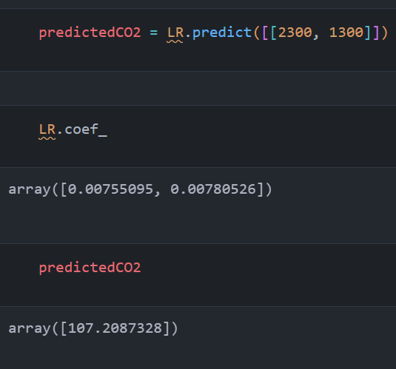
* The possible flaw in this model is to not consider the car model
* We can improve the model by considering the car company and the model of the car with weight and volume
* Model is based on prediction
* I have use co2 emission data set from Kaggle.com
* As it was downloaded from Kaggle it was clean
* It consisted of car company , model , weight , volume and co2 emission
* I used normal linear regression , polynomial regression , cross validation , k fold regression

My notebook: